

**2015S1-DM2198-DIGITAL ENTERTAINMENT PROJECT**

**Report**

**Done By: Sri Sham Haran s/o R. Raja (155129R)**

**Glence Low (155109T)**

**Gary Goh(155193D)**

**Jeffrey Low(152026L)**

**Supervisor: Mr Sim Tze Jan**

# Concept of Greed Reloaded

Greed Reloaded is a spin on the original classic Linux-based game Greed. Greed is a simple puzzle game in which the objective of the game is to erase as much of the screen as possible by moving around in a grid of numbers. The numbers in the grid represent distances. The character can be moved in all 8 directions by using the numpad. In Greed Reloaded a player can now play with a friend on the very same keyboard. Both characters will play on the same grid turn by turn. They can either use the numpad or “qweadzxc” to move. The objective of Greed Reloaded multiplayer is to score more points than the other player. There also time mode where they are given a time limited to try and get as many points as possible. This new features are added to help separated us from the old version of greed.

# schedule

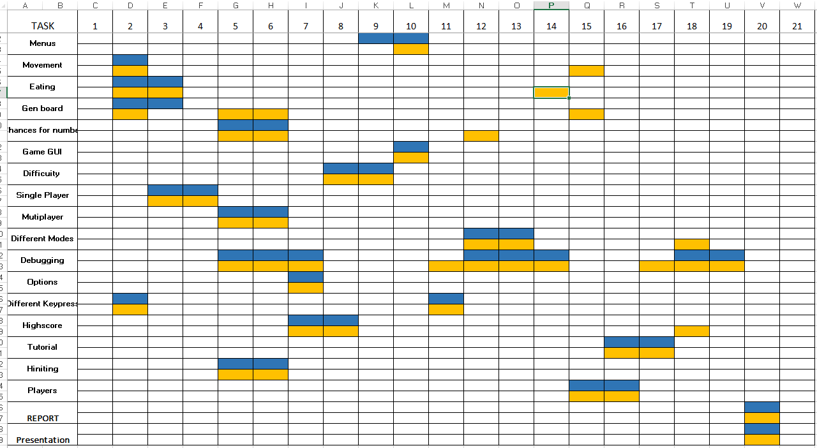

# Features

## Options

We have options to allow players to change how they want move, by default the controls will be numpad but if the player’s computer does not have it they can switch to the keyboard style where they will use “qweadzxc”. We have this as there are people without numpad or prefer to use keyboard. For multiplayer it will be using the same numpad unless they change it.

## Highscore

Another feature we have is highscore, where players can see the top 5 scores done by other players. The highscore is separated by which difficulty and mode they chose, this is so there will be fairness when comparing score for. At the end of the game, they will see whether or not they have beaten any other people highscore and if they did, they can enter their name to show other people their highscore.

## Multiplayer

Another feature we have is the multiplayer, in this mode instead of the normal gameplay where you just try to get as many points as possible, you will versus another player where the 2 of you will try to get higher points than the other, and the moment either of the players can’t move, the game ends and the game will check who has the higher amount of points and say who has won. After that it will take that score and check if it has beaten any other players’ highscore.

## tutorial

Another feature we have is tutorial, this is for the new player who is still trying to understand our game. In the tutorial there will be instructions telling the players how the game is played and what the different mode means. There will also be visuals to show the new player what to expect when they try out the game for real.

## time mode

Another feature we have is that apart from the normal mode is the time mode, where in single player, players are given 10 sec to try and get as many point as possible. For multiplayer, players are given a 10 sec time limit at the start of the game, then after that they will only have 3 sec to decide on each move. The game will end the moment either player can’t move.

## difficulty

Another feature is difficulty where players can select how difficult they want the game to be. There are 3 different kind of difficulties; easy, medium, and hard. The main difference between the 3 difficulties is the range of numbers and how likely the higher number will appear like for example for easy the number range is from 1 to 5 compared to hard which is from 1 to 9, the probability is also different for each difficulty where in hard the higher number has a higher probability of appearing compared to easy.

## hinting

Another feature we included is a hinting system. This is for players who want to see all the possible move they can make for those who don’t know which direction to move they can press the ‘H’ key and see all the possible moves they can make, the move will be highlighted to show the player where they will end up. They can only use the hints 3 times and this will be shown to the players in the game GUI.